BME Department of Highway and Railway Engineering

Thesis title

Thesis
BSc-SP-U-00x-23/24 /1 [Registry nr.]

[Author name: ]
[Semester: 2023/24/2]
Supervisor: Name, affiliation
Thesis advisor: Name, affiliation
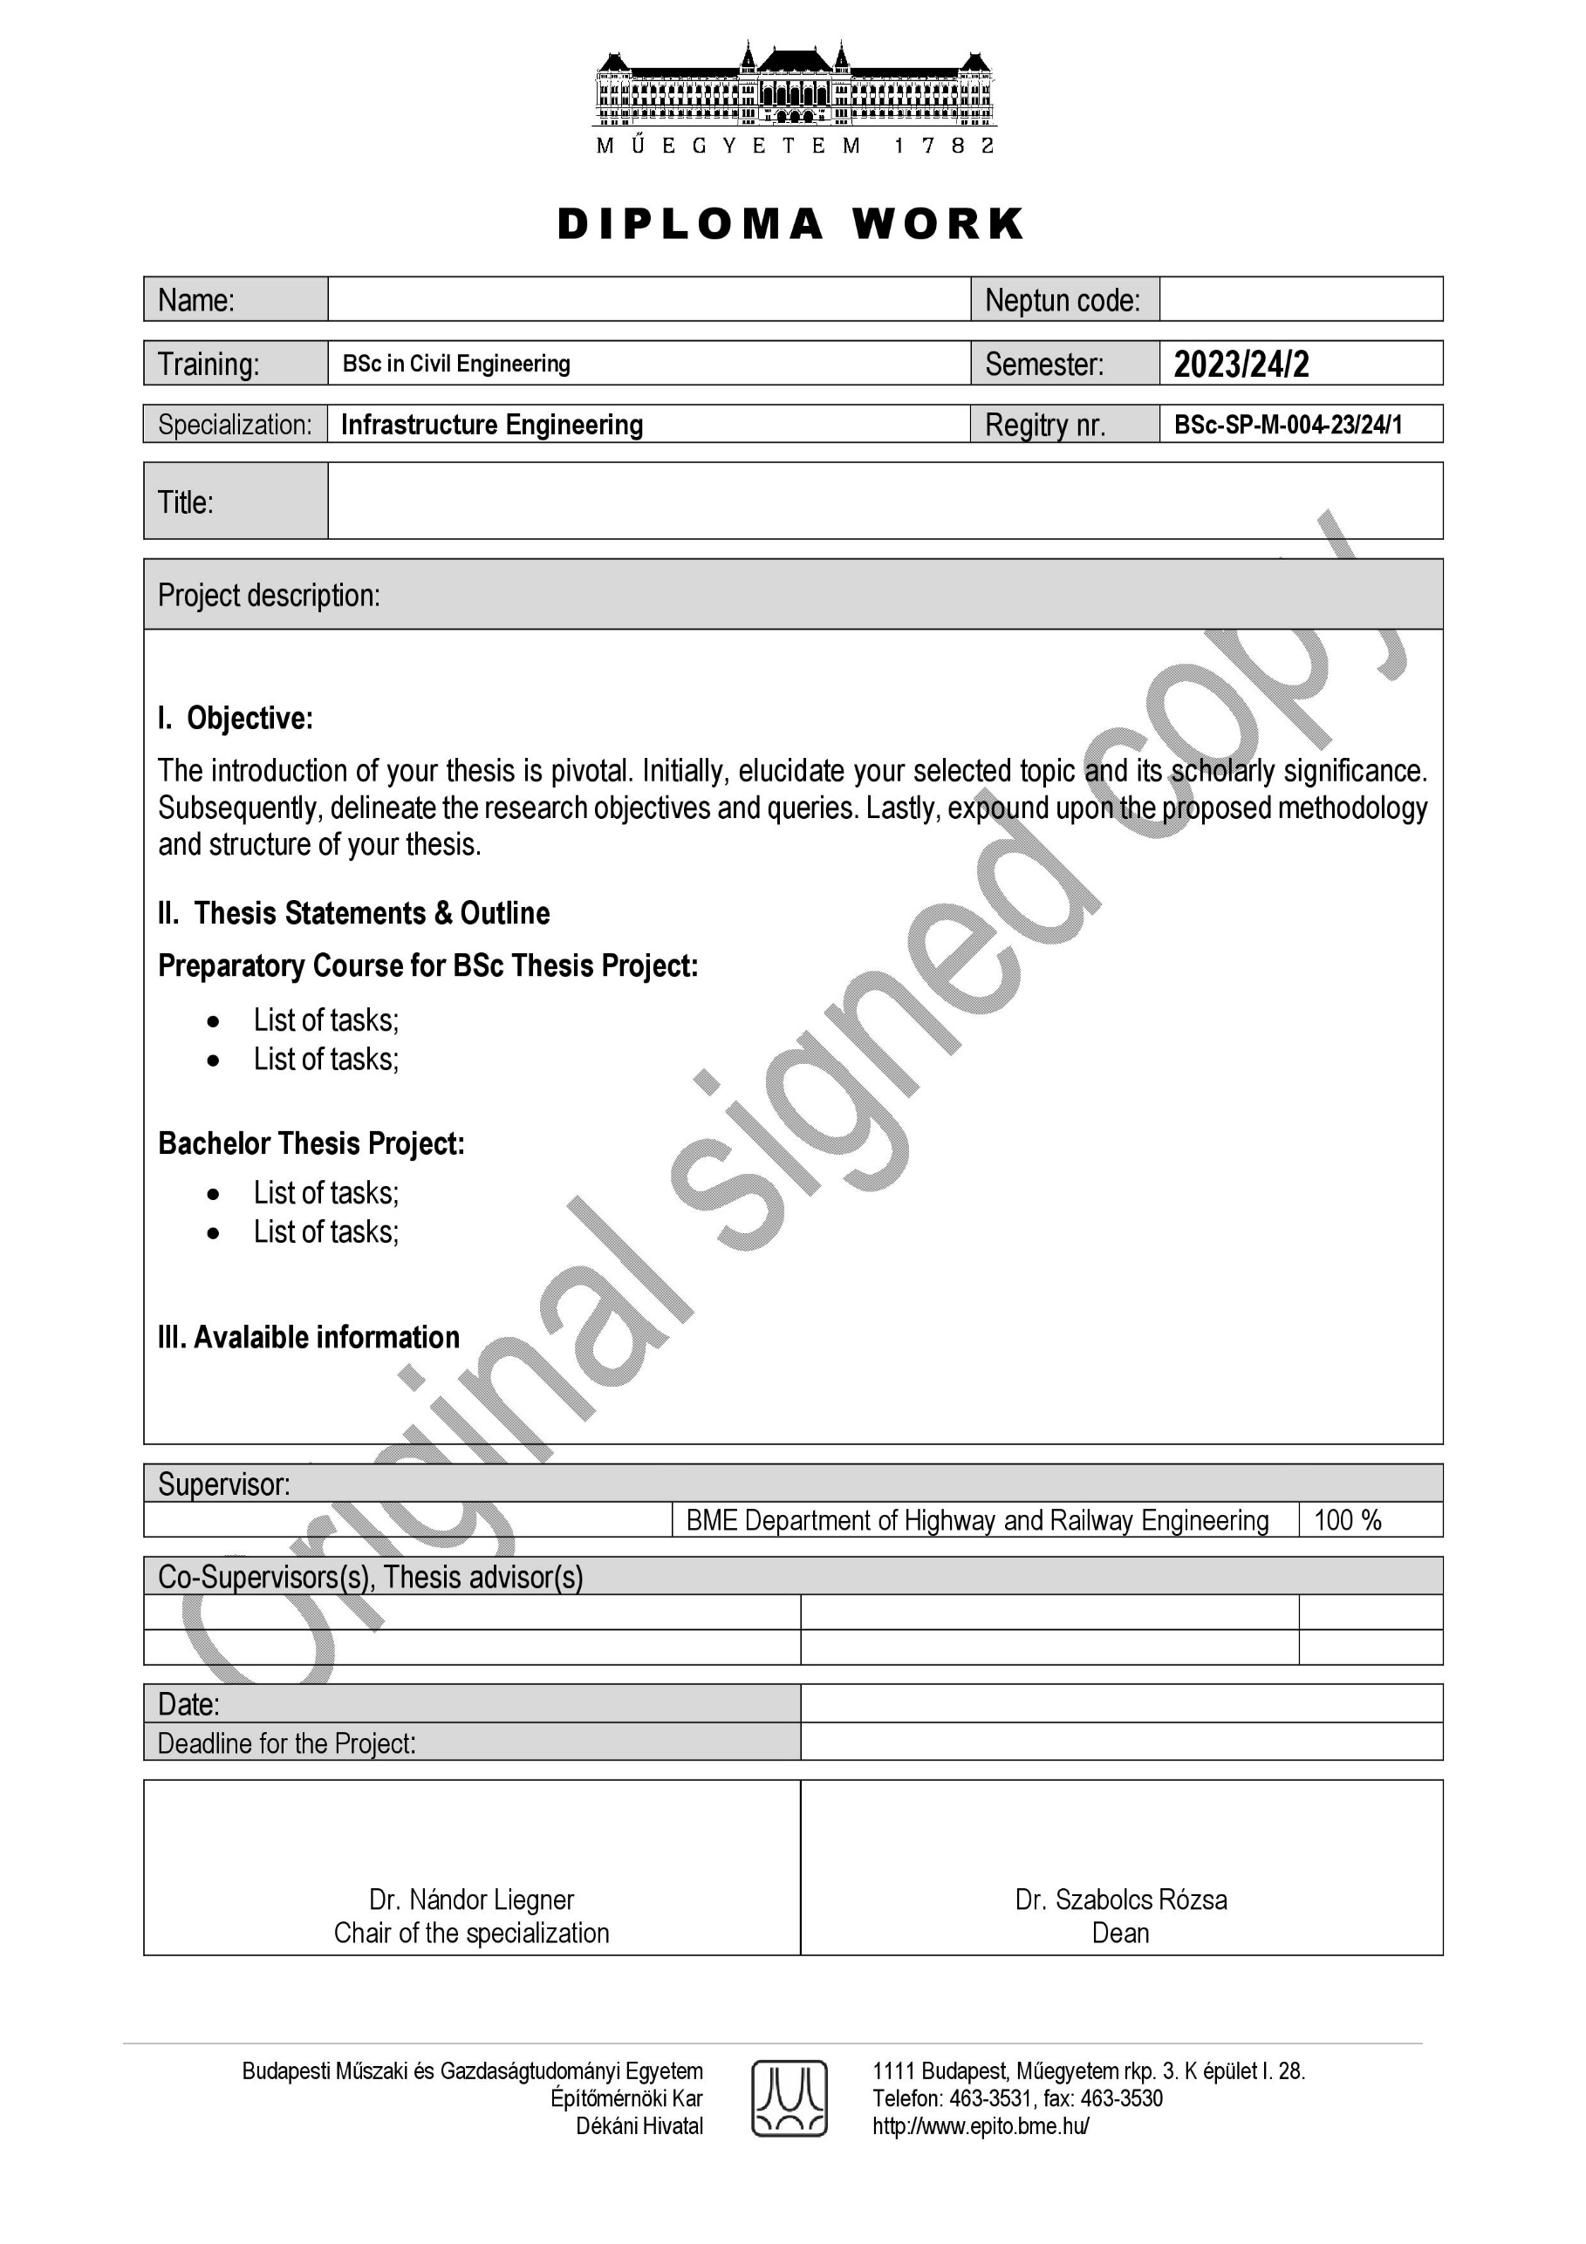

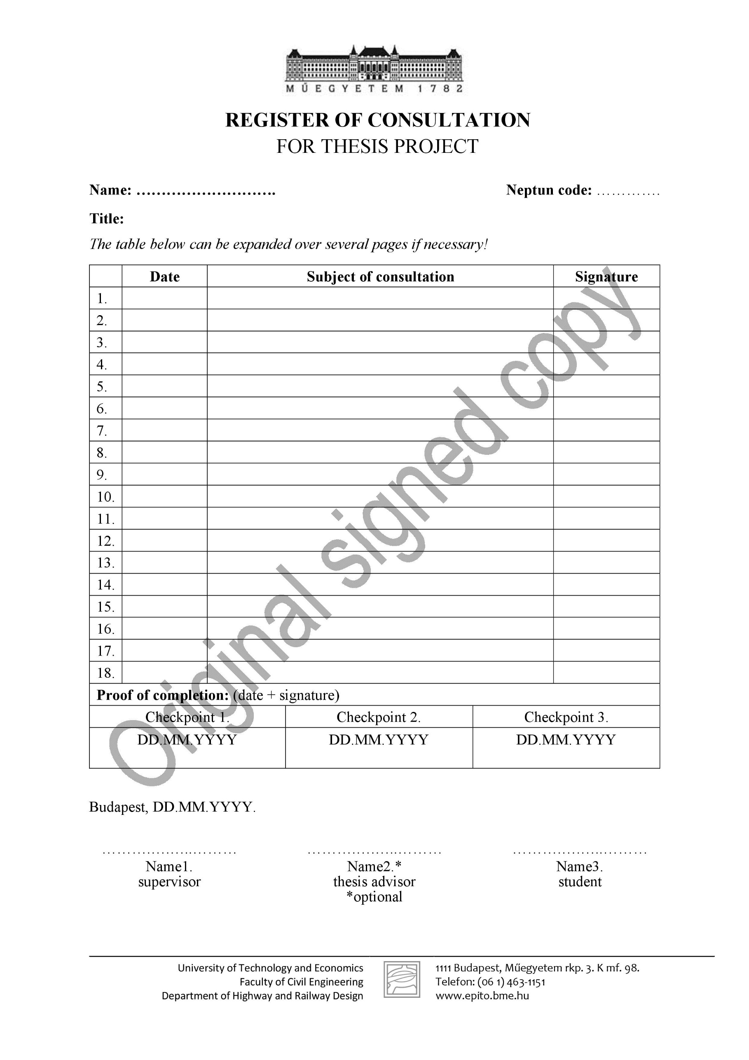

  - Summary in Hungarian
Keywords:
The executive summary summarises the topic addressed in the thesis, the steps of the work and a brief conclusion.
The maximum length of the summary is one page.

  - Abstract
Keywords:
The English-language summary summarises, in English, the topic addressed by the thesis, the steps of the work and a brief conclusion. The summary is, for all purposes, an English translation of the English summary.
The maximum length of the summary is one page.

  - Table of contents
1. Introduction 10
2. CHAPTERS, SECTIONS 11
2.1. Second level sub-sections 11
2.1.1. Third level sub-sections 11
2.1.2. The following third level sub-sections 11
2.2. Figures, pictures 12
2.3. Tables 13
2.4. Formulas 13
3. Summary 14
Bibliography 15
Annexes 16

  - List of Figures
Figure 2.1: Taurus in the Austrian mountains 9

  - List of Tables
Table 2.1: Mass per linear metre of rails 10

Introduction

[Normal] Manuscript preparation for Thesis project is a fairly simplified process. Everything you need for a properly formatted article is contained in this template document, which uses a feature of Microsoft Word called Styles. A style is a set of formatting characteristics that you can apply to text in your document to quickly change its appearance. When you apply a style, you apply a whole group of formats in one simple step. For example, you may want to format the sections headers to make them stand out. Instead of changing the headings one by one,

CHAPTERS, SECTIONS

The main chapters represent a logical unit: e.g. Introduction; History; Basic design data; Literature research; Performing laboratory tests; etc. It is always a good idea to start the main chapters on a new page, this template setting includes this automatically.

Second level sub-sections

Below the chapters, there are preferably sub-chapters that represent logical units within the main chapter. You should try to keep the titles of the chapters and subchapters short so that they fit in one line (also in the table of contents).

Third level sub-sections

The subchapters can be further separate into third level sub-sections.

The following third level sub-sections

Text

Fourth level sub-section
You should not use more than four heading levels in your document. If an additional heading level is needed, it should be done in plain text, not numbered, but highlighted, for example:
Advantages
Here are the benefits.
Disadvantages
Here are the disadvantages.
In many cases, it is necessary to create lists in the document. There are several levels of enumeration, we have defined a two-level enumeration in this template, more levels should be avoided. The listing styles are shown below:
- First item of first level list
- Second item of first level list
- First item of second level list
- Second item of secong level list
- Third item of first level list

In some cases, you may also need to create a numbered list. Below is a definition of this, which is also defined at two levels, but the second level is “numbered” in Latin letters.
- First item of the first level numbered list
- Next level within a numbered list
- Next level within a numbered list
- Second item of first level numbered list
- Third item of first level numbered list
- Next level within a numbered list
- Next level within a numbered list

Figures, pictures

The figures must always be referred to in the text and numbered continuously according to the main chapters. Below the figure, the number, title and source of the figure should be centered. If the source designation is a reference only (eg [1]), it can be in line with the title of the figure. You don't have to mark your own edit (!), But all other sources do. Spacing should be set before, after, and after the caption.
Trains can also run between mountains, as shown in Figure 2.1.
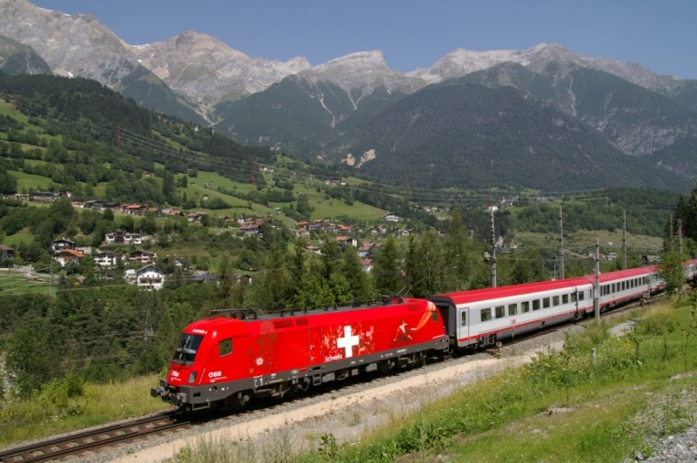
2.1Figure 1: Taurus in the Austrian mountains
[source: wikipedia]

Tables

As in the case of figures and pictures, they should be wrapped in the text (each where it is mentioned in the text) and numbered continuously according to the main chapters. Each table should have a short, objective title, in case of an adopted table the source should be indicated (as in the case of figures), in other cases the source of the data in the table should be indicated.

Rail sign | Mass per linear metre [kg/m] | Production length
I | 42,80 | 24,0 m
MÁV48 | 48,50 | 24,0 m
UIC54 | 54,43 | 21,0 m
2.1Table 1: Mass per linear metre of rails
[source: ISO EN 13674-1]

Formulas

If you need to insert formulas, the following styles are defined.
$m=11,8\frac{V^{2}}{R}-153a_{0}$ [syle: Egyenlet] (2.1)
where m is the superelevation [mm], V is the speed [km / h], R is the radius of curve [m], a₀ is the non-compensated lateral acceleration [m / s²] [style: Egyenletmagyarázat]
In both the main text and the explanation, we refer to physical signs in thin italics to distinguish them from then ormal text. In the explanation of the signs, the unit of measure is placed in [square brackets].

Summary

At the end of the essay, the conclusions drawn from your work on the topic should be summarised. This applies mainly to research, analysis and investigation papers, but may be omitted in the case of design work.

Bibliography

In the main text, the number referring to references should be in square brackets, according to the numbered reference method, e.g. [2]. Literal quotations must, of course, also be marked with quotation marks.
References should be collected at the end of the paper and set in the following order: Author surname, initials, title, publication, volume, page range, year. Refer to the examples included with these instructions. Numbering of references is automatic and sequential starting with number 1. Do check your final paper to ensure that references within the text correspond to the reference list at the end. The references given below are examples of the following: (1) paper in a journal; (2) paper in a journal with DOI; (3) book; (4) chapter in a book; (5) paper in conference proceedings; (6) personal communication; (7) web site.
[1] [Reference] Popp, K., Kruse, H., Kaiser, I.: Vehicle-Track Dynamics in the Mid Frequency Range, Vehicle System Dynamics, 31, pp. 423-464, 1999.
[2] [Reference] Lazauskas, M., Kutut, V., Zavadskas, E.K.: Multicriteria assessment of unfinished construction projects, GRAĐEVINAR, 67 (2015) 4, pp. 319-328, doi: 10.14256/JCE.1179.2014
[3] [Reference] Esveld, C.: Modern Railway Track, Second edition, TU-Delft, 2001.
[4] [Reference] Ahac, M., Lakusic, S.: Track Gauge Degradation Modelling on Small Urban Rail Networks: Zagreb Tram System Case Study (Chapter), Urban Transport Systems, ed. Yaghoubi, H., InTech, Rijeka, pp. 1-20, 2017.
[5] [Reference] Hartmann, T.: Virtual Management of Complex Infrastructure: Information Systems in the Age of BIG DATA, 4th International Conference on Road and Rail Infrastructure - CETRA 2016, pp. 21-36, Šibenik, Croatia, 23-25 May 2016.
[6] [Reference] Person, A. Personal communication, 20 November 2008, Position of Person in Company, Name of Company or University, City, Country.
[7] [Reference] Rubberized Concrete Noise Barriers (RUCONBAR), www.ruconbar.com, dd.mm.yyyy.

Annexes

Any parts of the work - especially those of a larger length - which would be distracting in the main body of the text, which are not essential to the meaning of the text, but which are relevant for the follow-up and the reader's more detailed interest, should be included in an appendix. Such as measurements taken by the student (e.g. traffic count sheets), laboratory test reports, databases, etc.

